The Controversy Over Fracking

Chima Ani

Georgia State University

**The Controversy Over Fracking**

**Introduction**

Fracking is a procedure that involves boring down into the earth and injecting shale rock with a high-pressure mixture of chemicals, sand, and water to discharge the gas and oil from the interior of the earth. Under the shale rock, there are trillions of cubic feet of gas, which can be reached through the hydraulic process. For instance, in northern and central England, approximate of 10 countries have gases lying below them. Geologists approximate that the total gas can supply the UK for about 500 years. However, it has not been approved since 2011 due to high profile application to fracking. Gas and oil that most countries use currently comes from the Maui gas fields of New Zealand and Middle East’s reserves. The reserves are conventional oil and gas, which are easily accessible through drilling. Conventional reserves are decreasing, which has led to new techniques employed to push the boundaries set in drilling gas and oil. Now, gas and oil are far gotten through ways which were initially thought not economically viable or physically impossible-fracking. In many countries, fracking has risen concerns rapidly. The fracking concerns are; possible pollution of groundwater by carcinogenic used chemicals, earthquakes emanation, greenhouse gas emissions and air pollution. The mentioned concerns are controversial issues raised by using fracking. The campaigners in most countries against fracking believe in the investments in renewable sources of energy as opposed to fossil fuels. In this research, will cover fracking, the rise of fracking, fracking controversy, the impact of fracking on the groundwater, worries and peer-reviewed studies on fracking, and the economic importance of fracking.

**Fracking**

The fracking process involves the use of fluid at a high pressure to fracture the rock. First, a well is drilled through the earth's crust, casings of steel are then cemented in place, and then use of explosive is employed to make holes via the casing into the rocks around it at the base level. Once the holes are formed, fracking fluid at higher pressure is pumped to crack the rock to create fissures and cracks to allow gas and oil to flow into the well. In conjunction with oil and gas, wastewater in large amounts flows out of the well (Meng, & Ashby, 2014). The wastewater is commonly known as “Produce water” which is very salty water that was trapped in the rock underground and fracking fluid getting to the surface may pass with it through flow back.

Fracking depends on the different properties of various rocks namely porosity and permeability.in order to understand fracking; the two process needs to be understood: permeability and porosity. The porosity of a rock is its ability to hold gas and oil. Porous rocks can trap gas and oil just like fluid in a sponge. Porous property helps to maintain the minerals together because they are buoyant and may escape. On the other hand, permeability nature of different rocks is the variation of rocks to allow gas and oil to flow through it (Meng, & Ashby, 2014). The degree of permeability depends on how well the holes are arranged in rocks and joined up. Impermeable stones have holes not interconnected, and the pores may remain trapped in isolated pores.

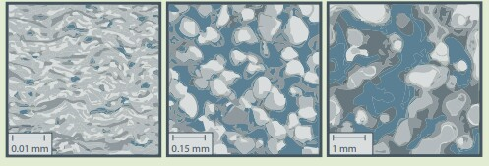

Source: Tommy Gracie, TERC

**Figure 1 Rocks with different porosity and permeability influencing passage of oil and gas.**

Rocks such as clay, pumice, and shale are impermeable yet very porous. On the other hand, limestone and sandstone are permeable and may allow gas and oil to move upwards. The upward movement of gas and oil may take an extended period slowly and may be stopped by a barrier which is an impermeable rock. The gas and oil, therefore, accumulate in the porous rocks acting as reservoirs (Meng, & Ashby, 2014). Gas and oil extracted are found in these overlaid reservoir rocks which are both permeable and porous. Drilling of oil and gas in the right place lets it flow out freely. Conversely, where permeability of the rock is low, extraction of these minerals may not take place. Due to this problem of mining, is when fracking techniques are used to access the oil and gas by creating new pathways through the impermeable rock making it permeable. Since fracking mainly aims to develop paths for oil and gas, there are three types of rocks on which the technique is used, namely; shale source rock, ‘tight sand' reservoir rock and coal seam source rock.

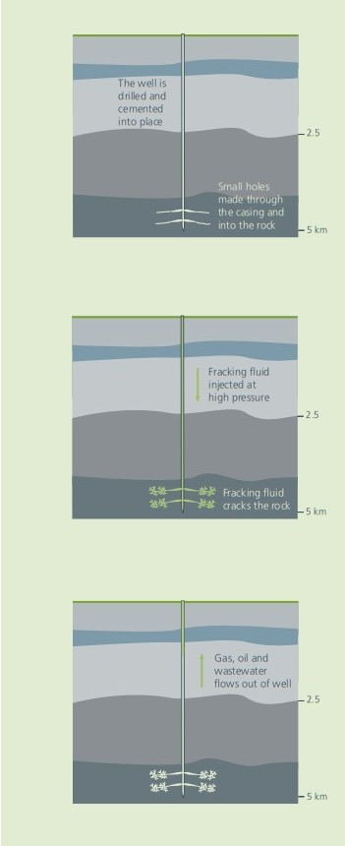

Figure 2 **Stages involved in fracking**.

**The Rise of Fracking**

The nineteenth century witnessed ‘well shooting’ explosive mechanism to crack the rock to get more oil and gas. In 1949, hydraulic fracturing was first carried out for commercial purpose. The process led to more production of oil and gasoline. Twenty years later, a new way of extracting oil and gas from gas wells was tested-stimulation of oil and gases by the explosion of nuclear devices. Use of high-pressure liquid later improved fracking. Therefore, ‘well shooting’ was then abandoned to pave the way for the use of new technologies which later advanced to current fracking (Boudet et al., 2014). Fracking led to more extraction of oil and gas and the United States Government stepped in to fund the research to drill more gas and oil. Larger amounts of sand and liquid were used than the old method. Thus, fracking is more hazardous than ‘well shooting.' Numerous tunnels could then be drilled in the oil fields. Large volumes of ‘slickwater' were used to frack shale gas. Globally, fracking process increased which led to more extraction of oil and gas and the advancement in technology has made fracking become complex over time.

**Fracking Controversy**

Environmental impacts due to fracking have raised concerns which have emerged alongside the rapid use of technology in the recent decade. A documentary in the United States filmed on Gasland enlightened the people on massive shale gas mining, and it received attention enormously. Contamination of groundwater was the much focus on natural gas mining. As result of this, campaigns against fracking set in, both in Europe and North America (Boudet et al., 2014). The campaigners expressed alarms about pollution of the aquifers, earthquakes, extreme levels of water use, air pollution, and climate modification.

Across the globe, different regions and countries have a mixed reaction from their governments on fracking. A vast number of regional governments have put moratoria or banned fracking. For instance, Bulgaria and France have banned the practice outright (Boudet et al., 2014). Currently, Victoria in Australia have prohibited fracking; nevertheless, New South Wales has lifted its moratorium. Queensland, coal seam gas has been projected to drill wells for about 20 years. The project was faced by environmentalists and alliance of farmers who raised concerns about environment and property rights and in the event pursued to stop the gas companies from shale gas mining. Prohibitions on fracking have also been witnessed in the United States in New Jersey, Vermont, and New York. Quebec in Canada is also likely to experience ban on fracking too. The standard argument about fracking in response, many reports around the globe have been written having their views on hydraulic fracturing. Royal Society in London resolved that fracking could be achieved through enforcement and implementation of best improved operational practices (Boudet et al., 2014). Internationally, International Energy Agency released its rules on shale gas and them termed it as ‘Golden Rules.' The rules are in the high-level principles which provide regulations and guidance policy regarding fracking.

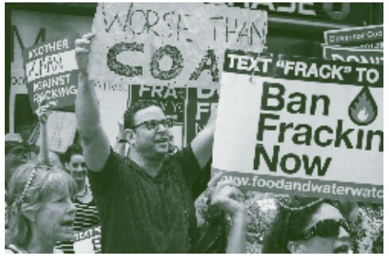

Source: Adam Welz

Figure 3 **A demonstration against fracking aimed at New York Governor in New York City.**

**Contamination of Water**

Shale gas is the most significant environmental risk and causes contamination either in lakes, local environments, in drinking supplies or domestic water as a result of extraction. The leaks that occur during storage and mixing of water, and during transportation matter most since the fracking process involves chemicals and minerals. The substances when released in water supply, can cause serious harm to the natural environment. Fracking fluid, for instance, when contaminated by water it has a lot of side effects when exposed to human beings. In the US, more than 300 chemicals are used in shale gas extraction and have led to many side effects (Vengosh, Warner, Jackson, & Darrah, 2013). Some of the results are cancer, respiratory system, skin, eye, nervous, immune and cardiovascular systems.

Fracking shale gas may take a million gallons of water. The gallons used are also combined with chemicals which are used in the fracking operation. For example, if 21,000 gallons are used, then approximate 76,000litters of chemicals are added, thus cause contamination of water if not handled carefully. Chemicals used in hydraulic fracturing, therefore, creates environmental hazards endangering flora and fauna.

Apart from chemicals used, fracking fluid may flow back, and in the process, it may pick toxins and minerals during the process. Flow back fluid at Lancashire Shale has notably high levels of chloride, sodium, bromide, lead, and zinc. The flow back, therefore, through the pathways of water they contaminate the groundwater (Vengosh et al., 2013). Thus, these pollutants contaminate groundwater as a result of integrity failure making it dangerous for consumption.

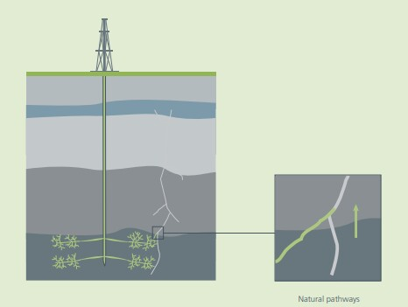

Source: Adapted from the US EPA, 2011b

Figure 4 **An illustration of pollutants migration through the natural pathways up the well.**

Spills and leakages can also contaminate surface runoff from wastewater which is poorly managed or via flow back. Failure to maintain stormwater during drilling can also lead to contamination of surface water. Moreover, construction of wells which are poorly designed can also lead to the impurity of water which may arise from aquifer penetration (Vengosh et al., 2013). Consequently, fracking has a significant impact on water, both surface runoff, and groundwater.

**Worries and Peer Reviews on Fracking**

Concerns raised about fracking are numerous and diverse. The uncertainties are more extensive and make people lack trust in the nations' strategic direction and the regulators because they go beyond the perils which people can imagine might pose on the physical environment. The risks involved in fracking range from physical damage to the environment to pollution of resources around.

To begin with is chemicals used in the fracking fluid, the method uses a lot of fluids as opposed to traditional gas and oil production which is friendly. The chemicals used, therefore, causes worries on the soil, water, and air which is polluted in the process. Wastewater injected into the ground may cause contamination of the aquifers (Fry, Briggle, & Kincaid, 2015). Chemicals and substances raise concerns about elements found in wastewater such as radioactive materials and heavy metals. In the process, the soil is also contaminated. Artificial land forming process spread wastes on agricultural land. Food may also be infected as well due to pollutant from fracking.

In 2011, Massachusetts Institute of Technology studied more than 40 incidents related to natural gas operations which caused environmental pollution as a result of fracking. Water pollution was, therefore, evidenced in the following ways; Texas, Pennsylvania, and Blacklick Creek Pennsylvania. In Texas, a peer-reviewed study published on a journal by the University of Texas established levels of contaminants such as barium, arsenic, strontium, and selenium in wells owned privately close to shale gas activities (Fry et al., 2015). The researchers argue that arsenic may not have flown directly from fracking, but nearby drilling may have dislodged the rust in the pipes which contain arsenic elements which may cause pollution.

In the year 2013, dangerous levels of salinity and radioactivity were detected from fracking fluid in Blacklick Creek Pennsylvania. The detection was on the water that feeds into water sources for western Pennsylvania discharged from Josephine Brine Treatment Facility which was examined. Levels of bromide, combined with radium, strontium, oxygen, and hydrogen isotopic compositions were present (Fry et al., 2015. The peer-reviewed journal concluded that disposal site of wastewater might not pose a danger if the area is not settled. However, the slow bioaccumulation of the chemicals such as radium may lead to the biological threat on fish.

Researchers from Duke University published a journal in 2013 inPennsylvania. The journal touched on the methane, propane, and ethane found in groundwater samples close to active fracking sites. The research was done in more than 140 homes in five counties. The samples had methane in them. However, the levels of methane concentration were different. In homes, especially those close to the gas well of about one kilometer, showed a high level of concentration, about six times (Fry et al., 2015. The level of methane in wells close to the gas wells was 24 times than those farther away. Propane was also detected in ten homes, and the levels of concentration differed. The gases are said to be induced during the fracking process.

The peer-reviewed evidence while posing a significant risk of water pollution and demonstrate proof that the ongoing fracking process is polluting water. Variation in the concentration of chemicals in wells close to shale wells is a clear indication that fracking has a negative impact on the environment and pollution of water in the region where it is carried out.

Additionally, some earthquakes are linked to fracking especially in countries which are geologically active. However, there is no direct evidence that only fracking can cause earthquakes. With significant impact on the surface. Studies carried by Columbia University, link seismicity with wastewater which was injected in the fracking sites that triggered earthquakes. In 2011, Blackpool region underwent tremors of a magnitude of about 2.2ML just after fracking in the Bowland shale by Cuadrilla Preese Hall Well (Fry et al., 2015). Royal Society also linked fracking to another seismic of magnitude 1.4ML which caused well-casing to be deformed. The observation was attributed to Cuadrilla fracturing due to transmission of pumped fluid to a nearby fault. The fault zone was close to the weak bedding planes of the Bowland Shale which made it vulnerable to tremors. Thus, it can be said that fracking has an impact and may trigger off earthquakes especially through injection of wastewater.

Climate change as result of hydraulic fracturing has raised concerns. The first is about an increase of carbon dioxide emissions due to using of gas and oil which deter investment in the renewable sources of energy. The second is methane which is a potent greenhouse gas which may be leaked into the atmosphere. The related peril of methane in the atmosphere causes global warming which is alarming and has to be halted.

**Economic Importance of Fracking**

Geological surveys show some countries have higher significant shale gas resources than others. The economic benefit derived from them varies according to shale gas resources available in respective countries. Gas and oil industry expansion is enormously positive. Stimulation of new economic activities creates job opportunities in the economy (Sovacool, 2014). Economic benefits bypass royalties and taxes captured by central governments in countries where hydraulic fracturing is carried out properly. Direct benefits like cheap oil and gas go to the local people. Utilities derived also depends on the geological structure of the state. Shales in different countries are geologically varying from other countries. For instance, US shales differ from those of UK. The UK shales are thicker, deeper, and more complex than those of US. Comparatively, in terms drilling, the UK shales costs are considerably higher. The UK data control is weak geologically hence have a significant loss to drill shale wells. As a result of this, the US has over 80,000 wells which are fracked in Ohio state as opposed to about 40,000 shales in the UK. Extraction of gas and oil varies from one place to another due to the different nature of the rock structure (Sovacool, 2014). Therefore, benefits from fracking are higher in countries with fewer faults and strong rock structure as opposed to those with many faulted areas where shales are located.

Globally, Bills by households on the use of gas in the US and UK does not reduce, because nations are part of global supply in the market. The quantity may increase in the market which becomes an added economic advantage worldwide. Thus, fracking has reduced energy crisis to some extent in the world.

**Conclusion**

Fracking as a process to extract oil and gas has risks which lead to environmental destruction which critically depend on each phase of the process. Due to its proximity to significant faults, aquifers, and methane gases, wells designed and quality must be appropriately made to avoid the effects. Handling of chemicals should also be done carefully to prevent leakages, spills, and wastes. Disposing of the same chemicals needs to done appropriately to curb environmental degradation. When fracking is carried out well, the severity and chance of damage to the environment cannot outweigh the economic benefits derived from fracking. However, when the extraction is done poorly, the risks involved may be higher. Therefore, management of fracking operations is vital.

References

Boudet, H., Clarke, C., Bugden, D., Maibach, E., Roser-Renouf, C., & Leiserowitz, A. (2014). “Fracking” controversy and communication: Using national survey data to understand public perceptions of hydraulic fracturing. *Energy Policy*, *65*, 57-67.

Fry, M., Briggle, A., & Kincaid, J. (2015). Fracking and environmental (in) justice in a Texas city. *Ecological Economics*, *117*, 97-107.

Meng, Q., & Ashby, S. (2014). Distance: A critical aspect of environmental impact assessment of hydraulic fracking. *The Extractive Industries and Society*, *1*(2), 124-126.

Sovacool, B. K. (2014). Cornucopia or curse? Reviewing the costs and benefits of shale gas hydraulic fracturing (fracking). *Renewable and Sustainable Energy Reviews*, *37*, 249-264.

Vengosh, A., Warner, N., Jackson, R., & Darrah, T. (2013). The effects of shale gas exploration and hydraulic fracturing on the quality of water resources in the United States. *Procedia Earth and Planetary Science*, *7*, 863-866.